**4.1.1:** **The institution has adequate facilities for teaching - learning. viz., classrooms, laboratories, computing equipment, etc.**

1. **Classrooms**

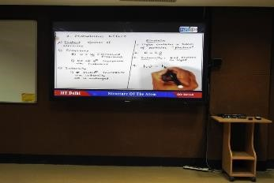

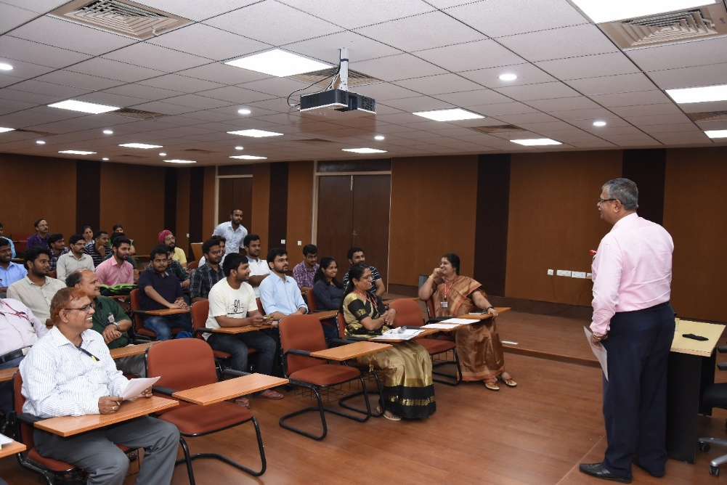

**IGCAR Classroom &**

**Video conference hall**

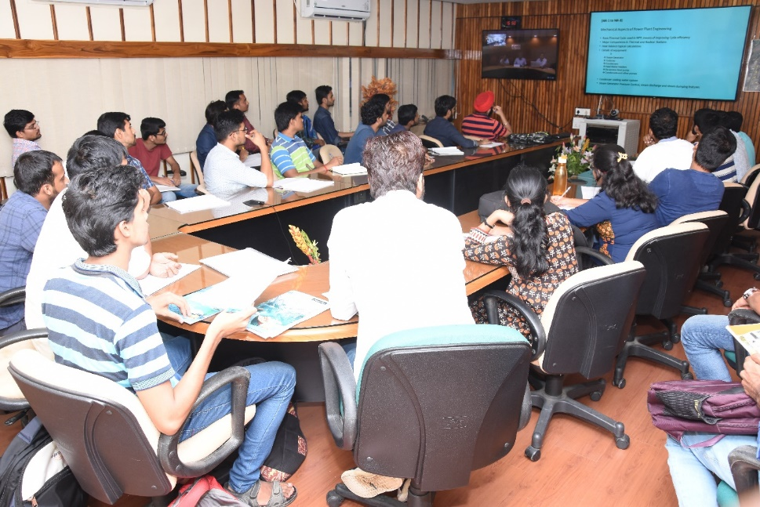

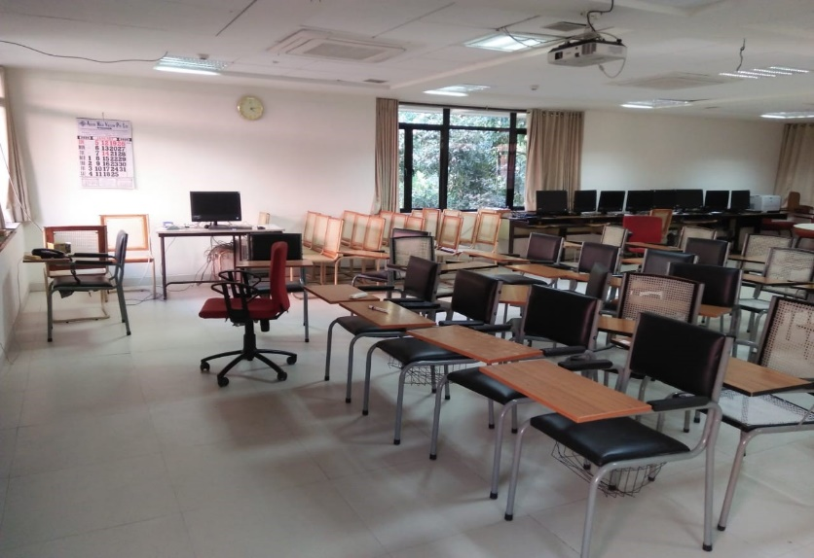

**IPR Classroom**

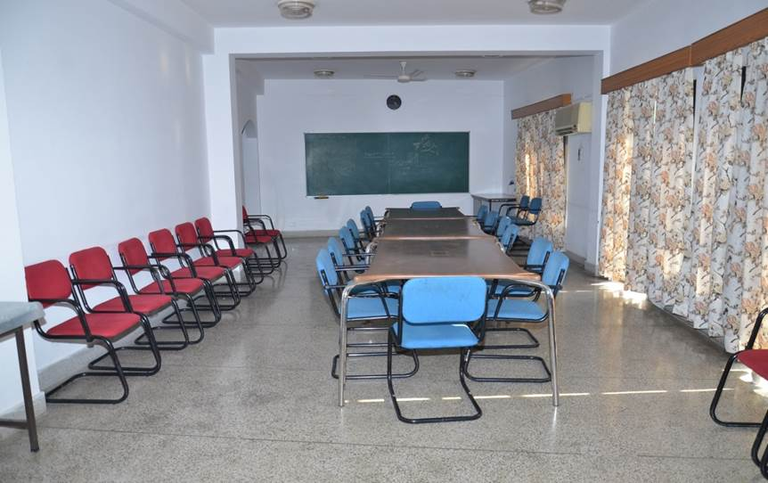

**HRI Lecture Hall**

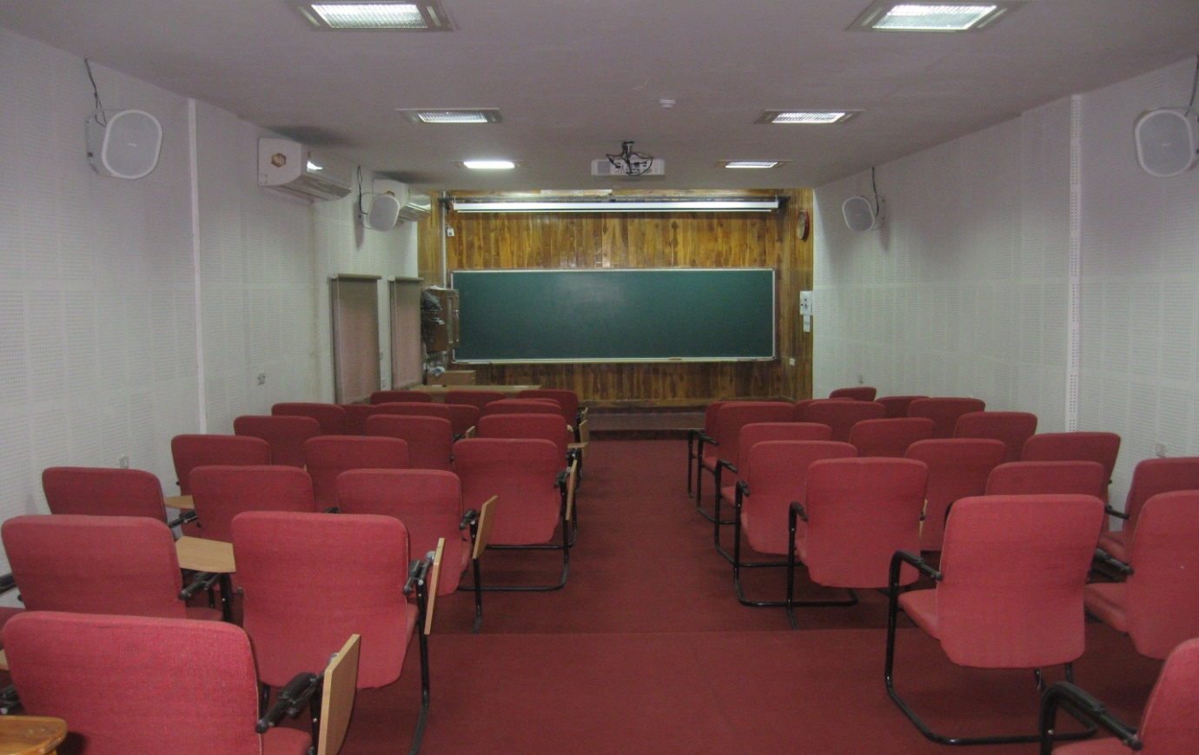

**HRI Lecture Hall**

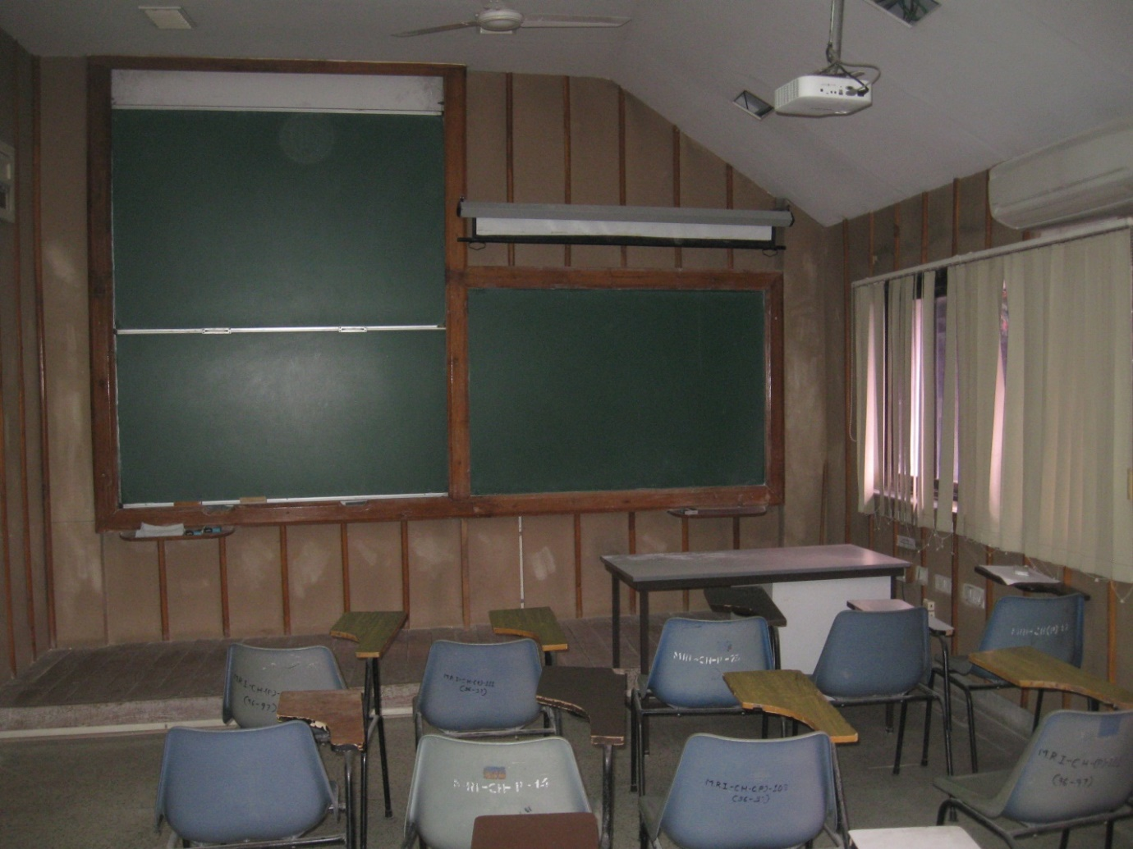

**HRI Seminar Hall 1**

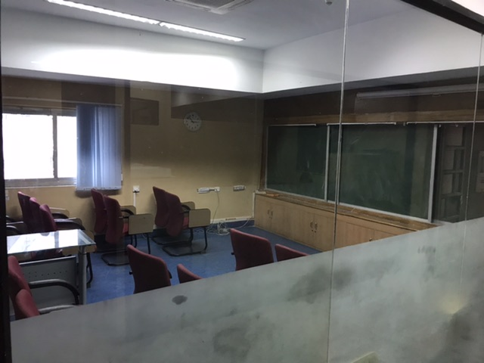

**HRI Lecture Hall 2**

1. **Laboratories**

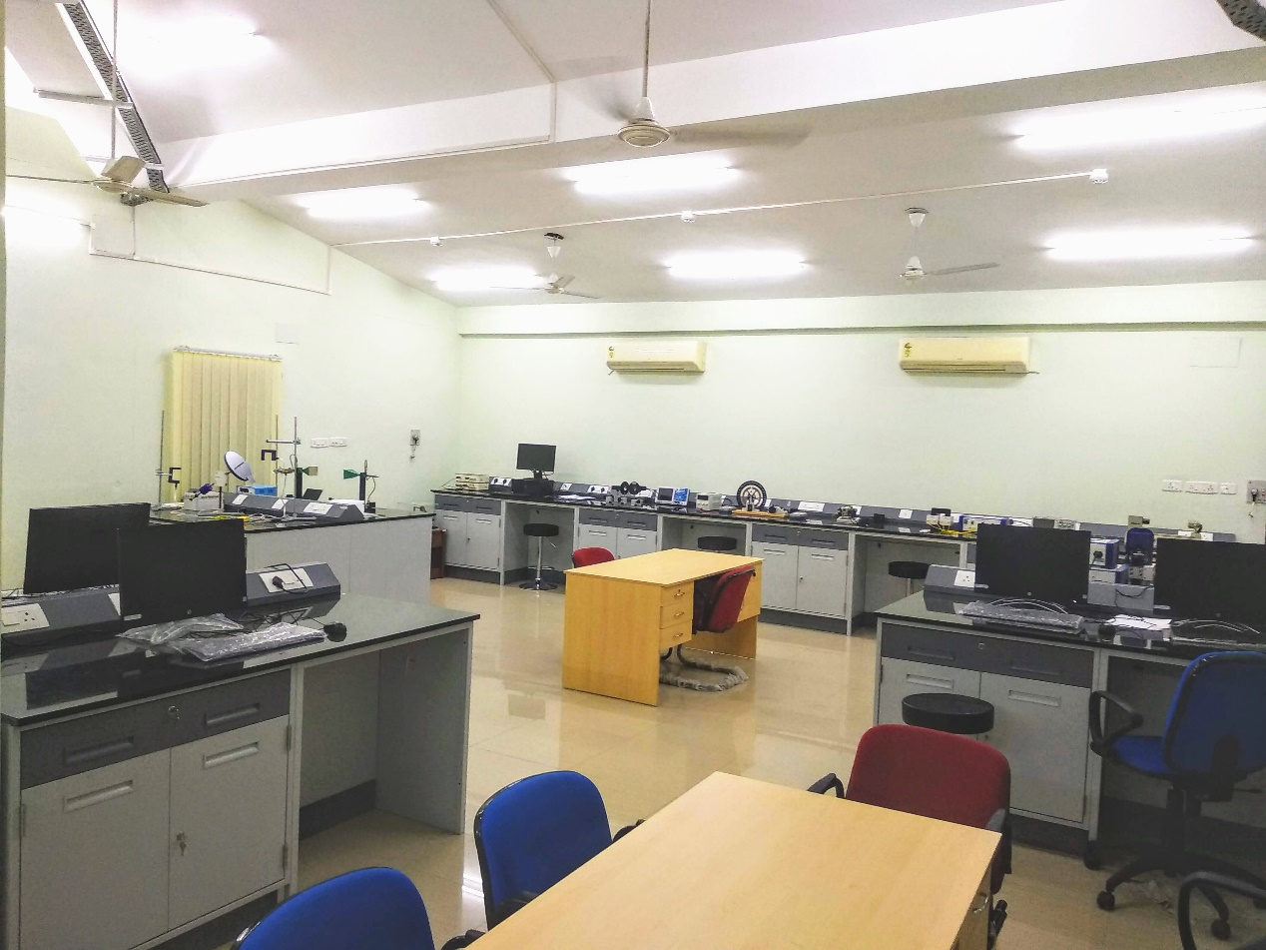

**HRI Physics Lab**

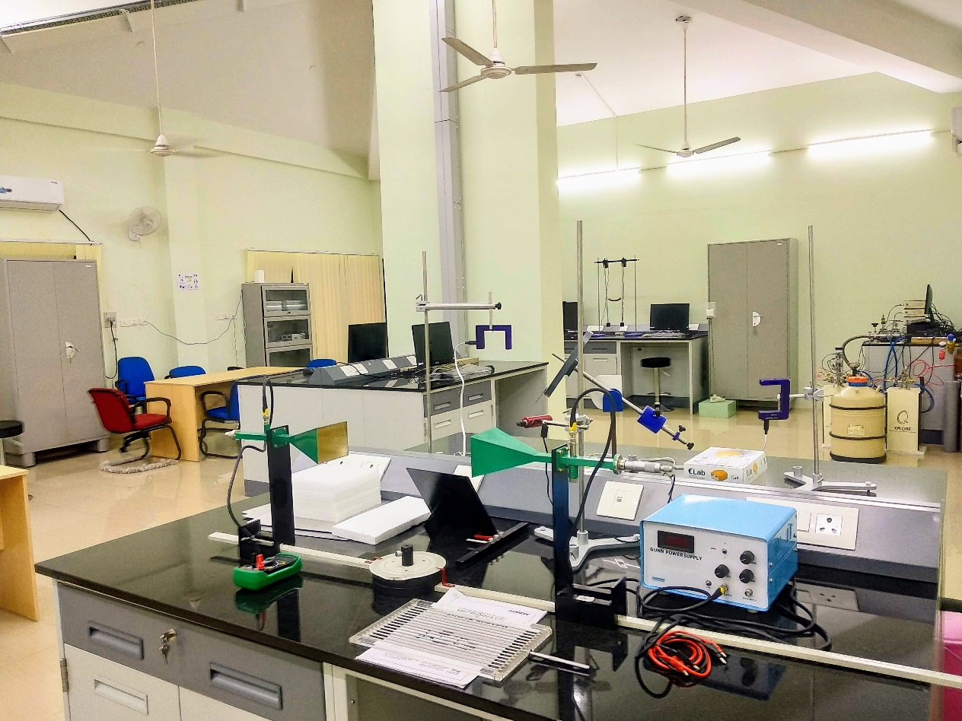

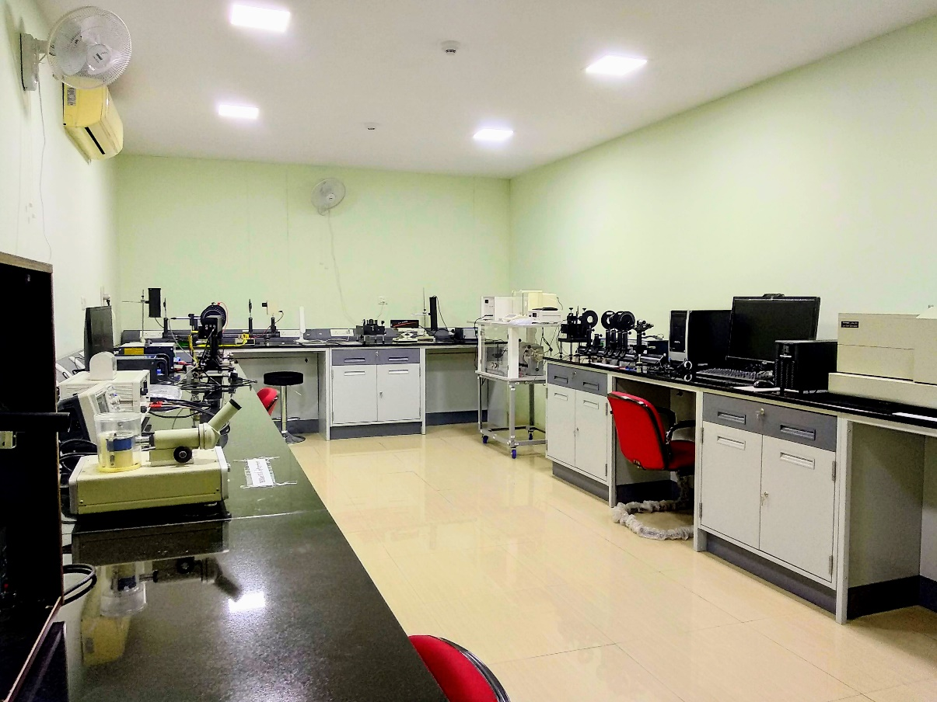

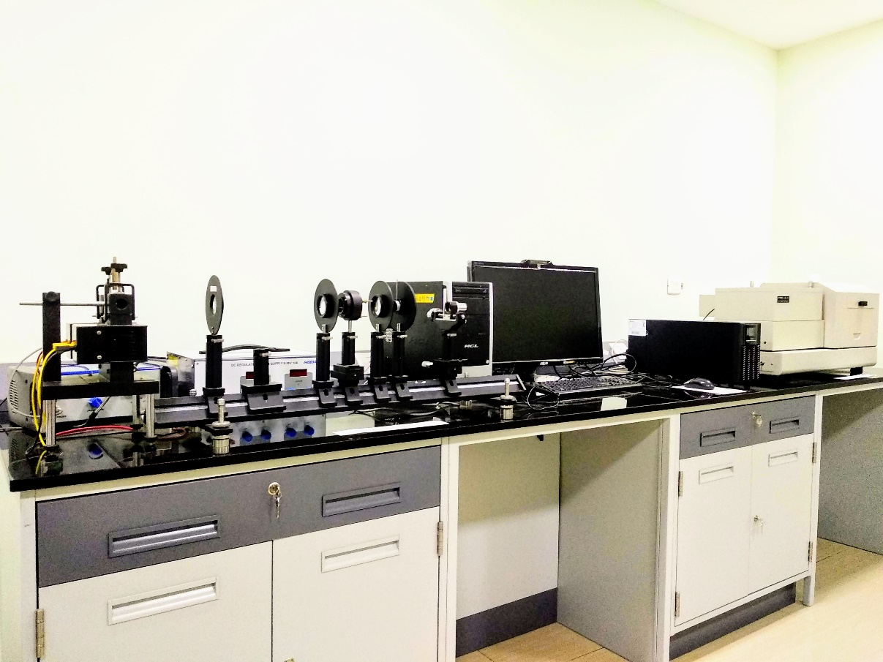

**HRI Physics Lab**

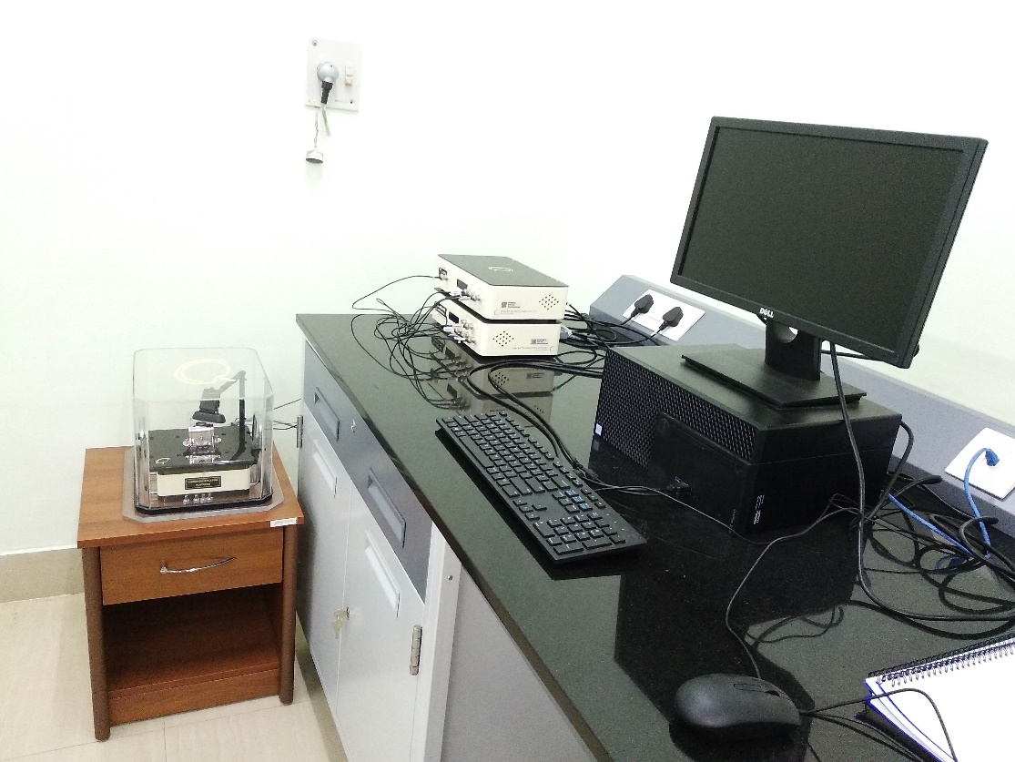

**STM Experiment**

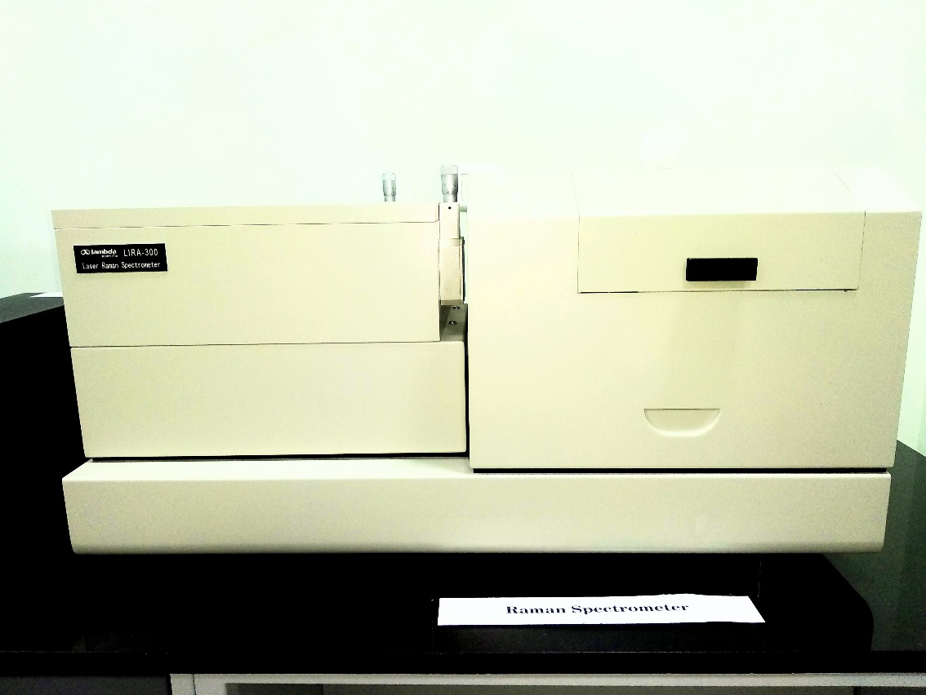

**RAMAN Spectrophotometer**

1. **Computer Labs and equipment**

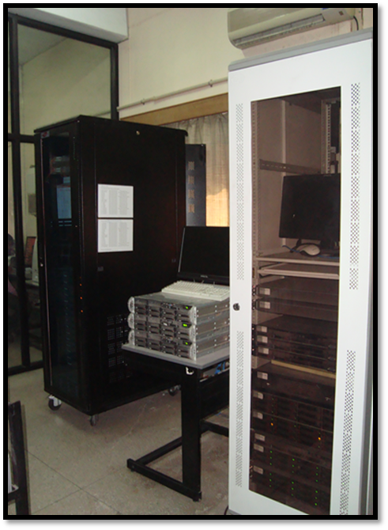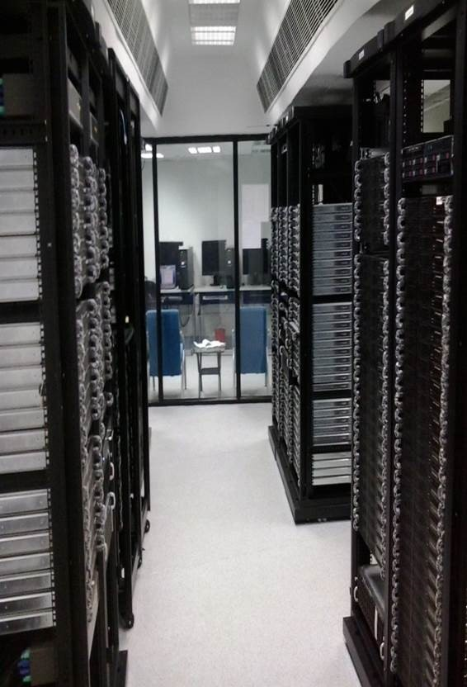

**HRI Cluster Computation facility HRI Central Server facility**

1. **Other academic related facilities**

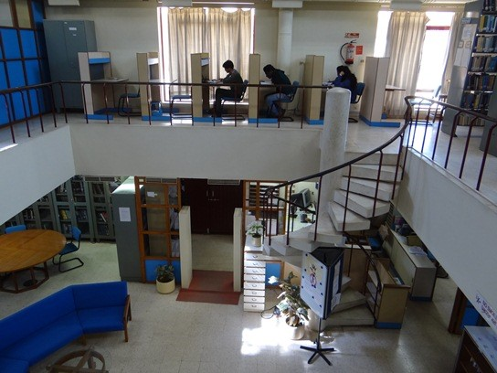

**IPR Library facilities**